**Note:** not a formal report but here are some notes I took along the way.

Reading the i2c devices connected to the Arduino

Arduino provides a scanner program to list the addresses of any devices on the i2c bus. I later learned that you can find this information in the datasheet. Connecting other lines to the breakout board can let you change the address but that is not necessary for this project’s purpose.

Mpu 9050 wiring sample

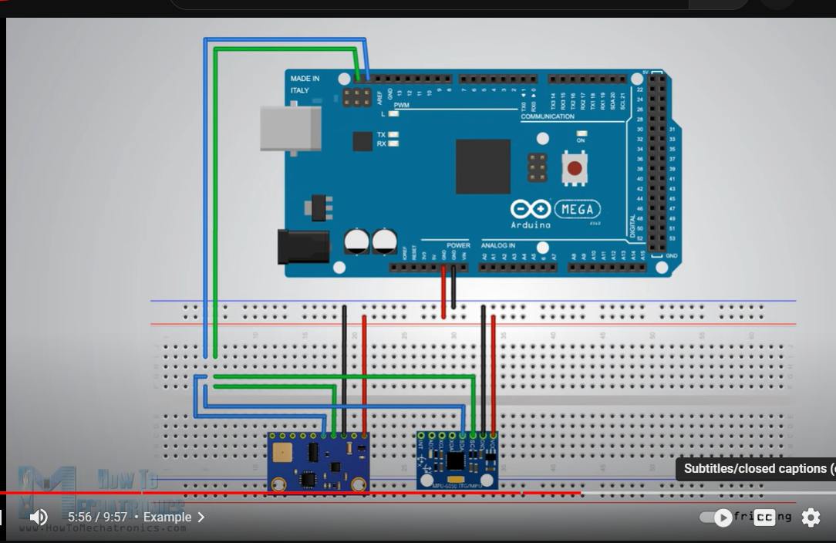

Servo wires

Accelerometer axis data retrieval. Data sheet page 29.

Power management register of the mpu:

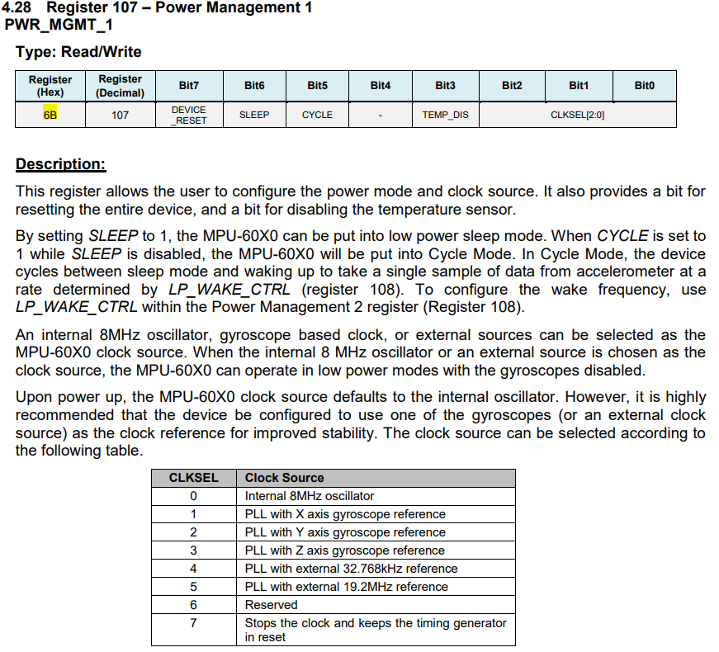

Accelerometer range selection. Sets and tests the range of the accelerometer axes.

Reading data from the accelerometer:

Resources used to study

I2c and mpu 6050 on gy-521

* Example mpu 6050 i2c test code (working test case to study): <https://learn-cnc.com/mpu-6050-example-i2c-primer/>
* How i2c works and using it with 6050 and other related controller: <https://www.youtube.com/watch?v=6IAkYpmA1DQ>
* Mpu 6050 datasheet: <https://www.alldatasheet.com/datasheet-pdf/pdf/1132807/TDK/MPU-6050.html>
* The gy-521 breakout board, how it relates to mpu 6050 controller, and i2c test code: <https://protosupplies.com/product/mpu-6050-gy-521-3-axis-accel-gryo-sensor-module/>

PWM and servo

* <https://docs.arduino.cc/learn/electronics/servo-motors>
* Controlling servo angle: [Servo - write() - Arduino Reference](https://www.arduino.cc/reference/en/libraries/servo/write/)

I2c and Arduino

* [requestFrom() - Arduino Reference](https://reference.arduino.cc/reference/en/language/functions/communication/wire/requestfrom/)
* [read() - Arduino Reference](https://reference.arduino.cc/reference/en/language/functions/communication/wire/read/)
* [endTransmission() - Arduino Reference](http://reference.arduino.cc/reference/en/language/functions/communication/wire/endtransmission/)

Serial and Arduino

* [sending integers over serial in arduino - Stack Overflow](https://stackoverflow.com/questions/58447816/sending-integers-over-serial-in-arduino)
* Graphical user interface, text, application

  Description automatically generated

([arduino send data from serial - Bing](https://www.bing.com/images/search?view=detailV2&ccid=UGo9hGTo&id=61B1D209A522B46DF0E5ECC01146355B59E278ED&thid=OIP.UGo9hGTow_UyxOUVugzADgHaFb&mediaurl=https%3a%2f%2fengineerzero.files.wordpress.com%2f2012%2f01%2fprocessing_to_arduino.jpg%3fw%3d1024%26h%3d750&cdnurl=https%3a%2f%2fth.bing.com%2fth%2fid%2fR.506a3d8464e8c3f532c4e515ba0cc00e%3frik%3d7XjiWVs1RhHA7A%26pid%3dImgRaw%26r%3d0&exph=750&expw=1024&q=arduino+send+data+from+serial&simid=607997447860026698&FORM=IRPRST&ck=5AA76473A019C41F7DAD55D912984E1A&selectedIndex=1&ajaxhist=0&ajaxserp=0))